Reg. No:
 | CHENNAI INSTITUTE OF TECHNOLOGY  Sarathy Nagar, Pudupedu, Chennai– 600 069.  Assessment II - OCTOBER 2022
Date | 19.10.2022 | Max. Marks | 50 Marks
Subject | CS3352/DIGITAL PRINCIPLES AND COMPUTER ORGANIZATION | Time | 1 hr 30 m
Branch | COMMON TO CSE, CSBS, AIDS and IT | Year/Semester | II/III
(SET-A)
 | Course Objective
 | To analyze and design combinational circuits.
 | To analyze and design sequential circuits.
 | To understand the basic structure and operation of a digital computer.
 | To study the design of data path unit, control unit for processor and to familiarize with the hazards.
 | To understand the concept of various memories and I/O interfacing.
 | Course Outcome
C202.1 | Design various combinational digital circuits using logic gates.
C202.2 | Design sequential circuits and analyze the design procedures.
C202.3 | Analyze the execution of an instruction.
C202.4 | Analyze the different types of control design and identify hazards.
C202.5 | Identify the characteristics of various memory systems and I/O communication.

Blooms Taxonomy(BT) Level :
K1-Remembering; K2-Understanding; K3-Applying; K4-Analyzing; K5-Evaluating; K6-Creating
 | PART-A 2 X 5 = 10(Answer all the questions)
1 | Write the procedure to design a synchronous sequential circuit. | C202.2 | K2 | [N/D-16]
2 | Realize T Flip Flop using JK Flip Flop | C202.2 | K2 | [A/M-17]
3 | Define race around condition in flip-flop | C202.2 | K2 | [N/D-16]
4 | Classify the instructions based on the operations they perform and give one example to each category. | C202.3 | K2 | A/M 2019
5 | What is register indirect addressing mode? When it is used? | C202.3 | K2 | N/D 2019
 | PART-B 2 X 12 =24
6 a | 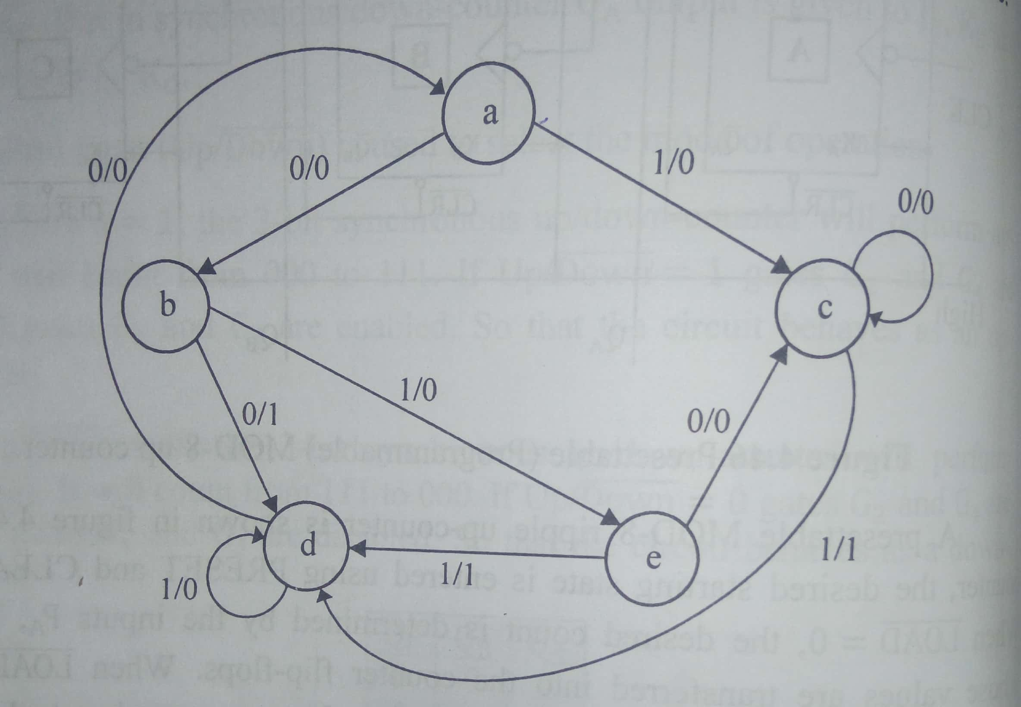  Design a synchronous sequential circuits for the below state diagram using JK-FF | C202.2 | K3 | A/M-2017
 | (or)
6 b | (i).Explain the operation of JK ,D , and T Flip-Flop with charactristcis and excitation table (9)  (ii). Explain the working Master/Slave JK FF (3) | C202.2 | K2 | A/M2017
7 a | Describe the different types of addressing mode with example. | C202.3 | K2 | A/M 2019
 | (or)
7 b (i) | Explain the components of a computer with the block diagram in detail. (6) | C202.3 | K2 | N/D 2019
(ii) | Explain the eight ideas of the computer architecture which empowered the computer design over the past decades. (6) | C202.3 | K2 | N/D 2019
 | PART-C 1 X 16=16
8 a | 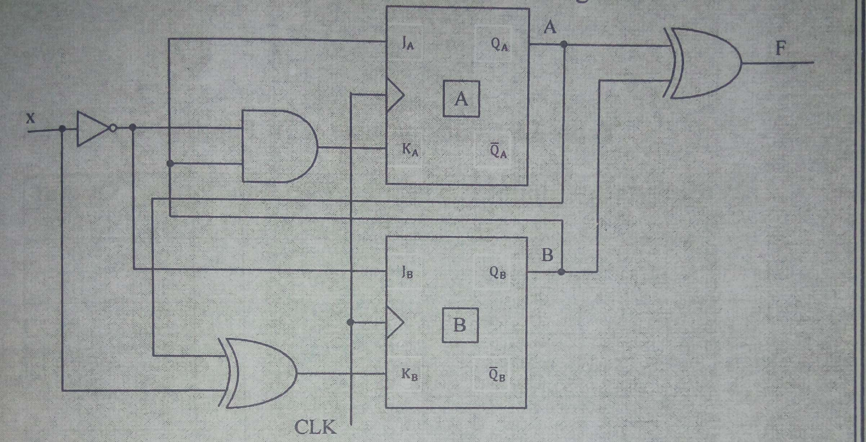  Analyze the below synchronous sequential circuit. | C202.2 | K2 | N/D 2020
 | (or)
8 b | Explain various instruction formats and illustrate the same with an example. | C202.3 | K2 | N/D 2017

Prepared by Verified by Approved by

Reg. No:
CHENNAI INSTITUTE OF TECHNOLOGY
Sarathy Nagar, Pudupedu, Chennai– 600 069.
Assessment II - OCTOBER 2022
Date | 19.10.2022 | Max. Marks | 50 Marks
Subject | CS3352/DIGITAL PRINCIPLES AND COMPUTER ORGANIZATION | Time | 1 hr 30 m
Branch | COMMON TO CSE, CSBS, AIDS and IT | Year/Semester | II/III
(SET – B)
 | Course Objective
 | To analyze and design combinational circuits.
 | To analyze and design sequential circuits.
 | To understand the basic structure and operation of a digital computer.
 | To study the design of data path unit, control unit for processor and to familiarize with the hazards.
 | To understand the concept of various memories and I/O interfacing.
 | Course Outcome
C202.1 | Design various combinational digital circuits using logic gates.
C202.2 | Design sequential circuits and analyze the design procedures.
C202.3 | Analyze the execution of an instruction.
C202.4 | Analyze the different types of control design and identify hazards.
C202.5 | Identify the characteristics of various memory systems and I/O communication.

Blooms Taxonomy(BT) Level :
K1-Remembering; K2-Understanding; K3-Applying; K4-Analyzing; K5-Evaluating; K6-Creating
 | PART-A 2 X 5 = 10(Answer all the questions)
1 | What is latch? What is the difference between latch and flip flop? | C202.2 | K2 | N/D-19
2 | Realize T Flip Flop using SR Flip Flop | C202.2 | K2 | A/M-20
3 | Write the state table and excitation table of T flip flop | C202.2 | K2 | A/M-17
4 | Write the components of a computer system and list their functions. | C202.3 | K2 | A/M2019
5 | Give the formula for CPU execution time for a program. | C202.3 | K2 | N/D 2016
 | PART-B 2 X 12 =24
6 a | Design a synchronous sequential circuit for the below state diagram using JK-FF  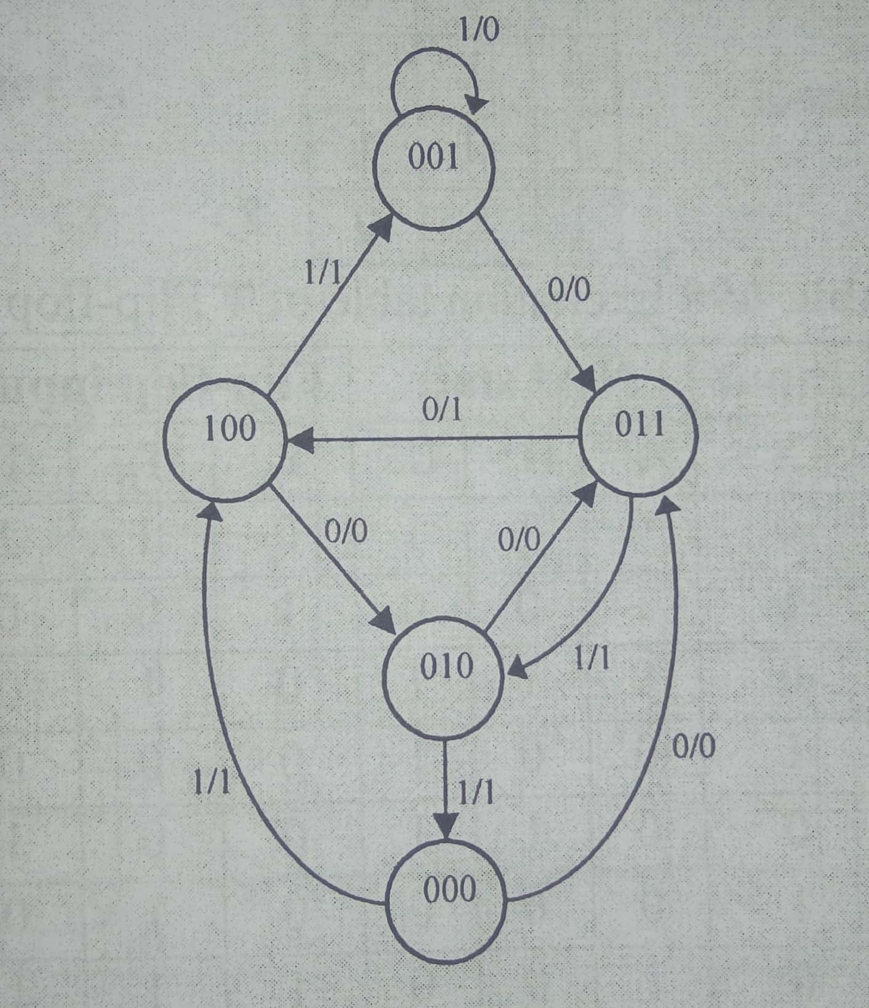 | C202.2 | K3 | N/D-10
 | (or)
6 b | Design a synchronous counter which counts in the sequence 000,001,010,011,100,101,110,111,000 using D flipflop | C202.2 | K3 | N/D 2019
7 a | Explain with an example about the operations and operands of the computer hardware. | C202.3 | K2 | N/D 2017
 | (or)
7 b | Explain addressing modes in a computer. Give one example instruction to each category. | C202.3 | K2 | N/D 2019
 | PART-C 1 X 16=16
8 a | Analyze the below synchronous sequential circuits  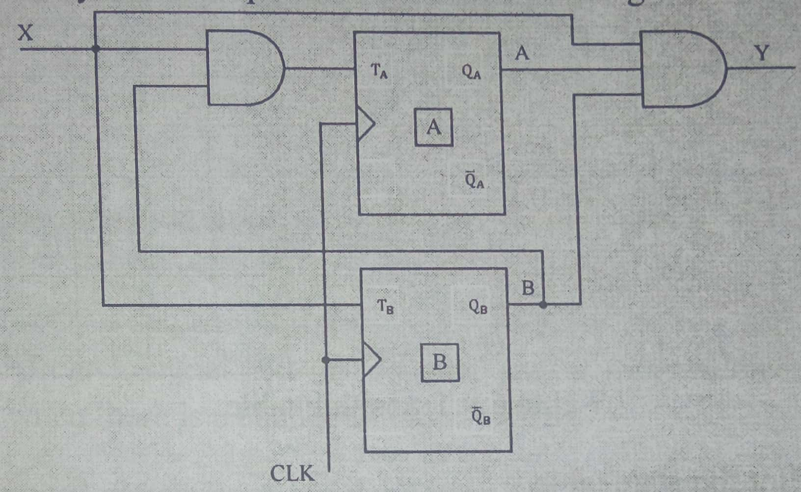 | C202.2 | K3 | A/M 2019
 | (or)
8 b | Explain Instruction Set Architecture in detail. | C202.3 | K2

Prepared by Verified by Approved by

